import numpy as np

import matplotlib.pyplot as plt

import seaborn as sns

import pandas as pd

import tensorflow as tf

import pickle

from tensorflow.keras.datasets import cifar10

# Load CIFAR-10 dataset

(train_images, train_labels), (test_images, test_labels) = cifar10.load_data()

# CIFAR-10 class names

class_names = ['Airplane', 'Automobile', 'Bird', 'Cat', 'Deer', 'Dog', 'Frog', 'Horse', 'Ship', 'Truck']

# Check if precomputed data is available

try:

    with open('cifar10_stats.pkl', 'rb') as f:

        basic_stats, channel_stats, mean_images = pickle.load(f)

    print("Loaded precomputed statistics and mean images from file.")

except FileNotFoundError:

    print("No precomputed data found. Calculating statistics...")

    # Calculate basic statistics about the images

    mean_pixel_value = train_images.mean()

    std_pixel_value = train_images.std()

    min_pixel_value = train_images.min()

    max_pixel_value = train_images.max()

    # Create a DataFrame for basic statistics

    basic_stats = pd.DataFrame({

        'Statistic': ['Mean', 'Standard Deviation', 'Min', 'Max'],

        'Pixel Value': [mean_pixel_value, std_pixel_value, min_pixel_value, max_pixel_value]

    })

    # Calculate per-channel statistics

    mean_per_channel = train_images.mean(axis=(0, 1, 2))

    std_per_channel = train_images.std(axis=(0, 1, 2))

    # Create a DataFrame for per-channel statistics

    channel_stats = pd.DataFrame({

        'Channel': ['Red', 'Green', 'Blue'],

        'Mean Pixel Value': mean_per_channel,

        'Standard Deviation': std_per_channel

    })

    # Calculate mean images for each class

    mean_images = []

    for i in range(10):

        mean_image = train_images[train_labels.ravel() == i].mean(axis=0)

        mean_images.append(mean_image)

    # Save calculated statistics and mean images

    with open('cifar10_stats.pkl', 'wb') as f:

        pickle.dump((basic_stats, channel_stats, mean_images), f)

    print("Statistics and mean images saved to file.")

# Display the shape of the dataset

print(f'Train images shape: {train_images.shape}')

print(f'Train labels shape: {train_labels.shape}')

print(f'Test images shape: {test_images.shape}')

print(f'Test labels shape: {test_labels.shape}')

# Display basic statistics

print("Basic Statistics of Pixel Values in CIFAR-10 Training Set:")

print(basic_stats)

# Display per-channel statistics

print("\nPer-Channel Statistics of Pixel Values in CIFAR-10 Training Set:")

print(channel_stats)

# Function to display a grid of images

def plot_image_grid(images, labels, class_names, rows=4, cols=4):

    fig, axes = plt.subplots(rows, cols, figsize=(12, 12))

    axes = axes.ravel()

    for i in np.arange(0, rows * cols):

        axes[i].imshow(images[i])

        axes[i].set_title(class_names[int(labels[i])])

        axes[i].axis('off')

    plt.subplots_adjust(hspace=0.5)

    plt.show()

# Plot a 4x4 grid of images from the training dataset

plot_image_grid(train_images, train_labels, class_names)

# Show an individual image with its label

def plot_single_image(index):

    plt.figure(figsize=(4, 4))

    plt.imshow(train_images[index])

    plt.title(f'Label: {class_names[int(train_labels[index])]}')

    plt.axis('off')

    plt.show()

# Plot a single image (e.g., image at index 0)

plot_single_image(0)

# Display the distribution of classes in the training dataset

plt.figure(figsize=(12, 6))

sns.countplot(x=train_labels.ravel(), palette='viridis')

plt.xlabel('Class')

plt.ylabel('Frequency')

plt.xticks(np.arange(len(class_names)), class_names, rotation=45)

plt.title('Class Distribution in CIFAR-10 Training Set')

plt.show()

# Plot the distribution of pixel values

plt.figure(figsize=(10, 5))

sns.histplot(train_images.ravel(), bins=50, color='blue', kde=True)

plt.xlabel('Pixel Value')

plt.ylabel('Frequency')

plt.title('Distribution of Pixel Values in Training Set')

plt.show()

# Plot the mean image of each class

fig, axes = plt.subplots(2, 5, figsize=(15, 6))

axes = axes.ravel()

for i in range(10):

    axes[i].imshow(mean_images[i].astype(np.uint8))

    axes[i].set_title(class_names[i])

    axes[i].axis('off')

plt.subplots_adjust(hspace=0.5)

plt.show()

# Display class counts as a bar plot

plt.figure(figsize=(10, 6))

sns.barplot(x=class_names, y=class_counts, palette='viridis')

plt.xlabel('Class')

plt.ylabel('Count')

plt.title('Class Frequency in CIFAR-10 Training Set')

plt.xticks(rotation=45)

plt.show()

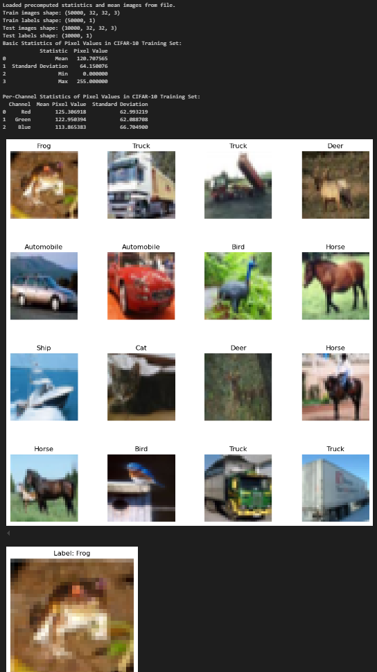

import numpy as np

import pandas as pd

import seaborn as sns

import matplotlib.pyplot as plt

import pickle

from tensorflow.keras.datasets import cifar10

from sklearn.decomposition import PCA

# Load CIFAR-10 dataset

(train_images, train_labels), (test_images, test_labels) = cifar10.load_data()

# CIFAR-10 class names

class_names = ['Airplane', 'Automobile', 'Bird', 'Cat', 'Deer', 'Dog', 'Frog', 'Horse', 'Ship', 'Truck']

# Check if precomputed data is available

try:

    with open('cifar10_stats.pkl', 'rb') as f:

        basic_stats, channel_stats, mean_images = pickle.load(f)

    print("Loaded precomputed statistics and mean images from file.")

except FileNotFoundError:

    print("No precomputed data found. Calculating statistics...")

    # Calculate basic statistics about the images

    mean_pixel_value = train_images.mean()

    std_pixel_value = train_images.std()

    min_pixel_value = train_images.min()

    max_pixel_value = train_images.max()

    # Create a DataFrame for basic statistics

    basic_stats = pd.DataFrame({

        'Statistic': ['Mean', 'Standard Deviation', 'Min', 'Max'],

        'Pixel Value': [mean_pixel_value, std_pixel_value, min_pixel_value, max_pixel_value]

    })

    # Calculate per-channel statistics

    mean_per_channel = train_images.mean(axis=(0, 1, 2))

    std_per_channel = train_images.std(axis=(0, 1, 2))

    # Create a DataFrame for per-channel statistics

    channel_stats = pd.DataFrame({

        'Channel': ['Red', 'Green', 'Blue'],

        'Mean Pixel Value': mean_per_channel,

        'Standard Deviation': std_per_channel

    })

    # Calculate mean images for each class

    mean_images = []

    for i in range(10):

        mean_image = train_images[train_labels.ravel() == i].mean(axis=0)

        mean_images.append(mean_image)

    # Save calculated statistics and mean images

    with open('cifar10_stats.pkl', 'wb') as f:

        pickle.dump((basic_stats, channel_stats, mean_images), f)

    print("Statistics and mean images saved to file.")

# Display the shape of the dataset

print(f'Train images shape: {train_images.shape}')

print(f'Train labels shape: {train_labels.shape}')

print(f'Test images shape: {test_images.shape}')

print(f'Test labels shape: {test_labels.shape}')

# Display basic statistics

print("Basic Statistics of Pixel Values in CIFAR-10 Training Set:")

print(basic_stats)

# Display per-channel statistics

print("\nPer-Channel Statistics of Pixel Values in CIFAR-10 Training Set:")

print(channel_stats)

# Perform PCA to reduce dimensionality of images for visualization purposes

n_samples = 1000  # Use a subset of the data for faster computation

flat_images = train_images[:n_samples].reshape(n_samples, -1)

pca = PCA(n_components=2)

principal_components = pca.fit_transform(flat_images)

# Create a DataFrame with PCA components and labels

pca_df = pd.DataFrame({

    'PCA1': principal_components[:, 0],

    'PCA2': principal_components[:, 1],

    'Label': train_labels[:n_samples].ravel()

})

# Plot PCA components to visualize class separability

plt.figure(figsize=(10, 8))

sns.scatterplot(x='PCA1', y='PCA2', hue='Label', palette='tab10', data=pca_df, legend='full', alpha=0.7)

plt.title('PCA of CIFAR-10 Training Set')

plt.xlabel('PCA Component 1')

plt.ylabel('PCA Component 2')

plt.legend(class_names)

plt.show()

# Filter data by specific classes for further analysis

# Example: Filtering only 'Airplane' and 'Automobile' classes

filtered_indices = np.where((train_labels == 0) | (train_labels == 1))[0]

filtered_images = train_images[filtered_indices]

filtered_labels = train_labels[filtered_indices]

# Display filtered dataset information

print(f'Filtered images shape: {filtered_images.shape}')

print(f'Filtered labels shape: {filtered_labels.shape}')

# Display the distribution of the filtered classes

plt.figure(figsize=(8, 4))

sns.countplot(x=filtered_labels.ravel(), palette='viridis')

plt.xlabel('Class')

plt.ylabel('Frequency')

plt.xticks([0, 1], ['Airplane', 'Automobile'], rotation=45)

plt.title('Class Distribution in Filtered CIFAR-10 Dataset')

plt.show()

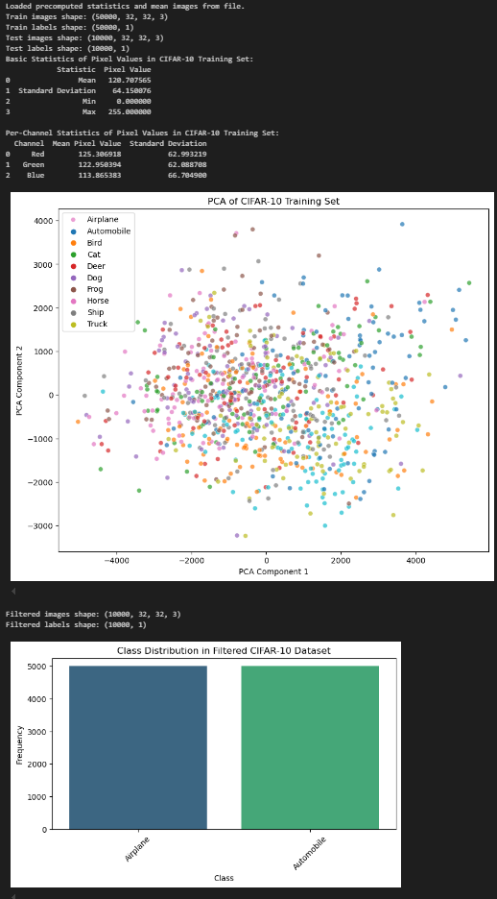

import matplotlib.pyplot as plt

import numpy as np

import seaborn as sns

from sklearn.metrics import confusion_matrix, classification_report

from tensorflow.keras.datasets import cifar10

from tensorflow.keras.models import Sequential

from tensorflow.keras.layers import Dense, SimpleRNN, Reshape, Flatten, Input, LSTM, TimeDistributed, GRU, Bidirectional

from tensorflow.keras.optimizers import Adam

import tensorflow as tf

# Set memory growth for GPU (if available)

gpus = tf.config.experimental.list_physical_devices('GPU')

if gpus:

    try:

        for gpu in gpus:

            tf.config.experimental.set_memory_growth(gpu, True)

    except RuntimeError as e:

        print(e)

# Load and preprocess CIFAR-10 dataset

(x_train, y_train), (x_test, y_test) = cifar10.load_data()

x_train, x_test = x_train / 255.0, x_test / 255.0

class_names = ['airplane', 'automobile', 'bird', 'cat', 'deer',

               'dog', 'frog', 'horse', 'ship', 'truck']

# Function to plot model accuracy and loss

def plot_training_history(history, model_name):

    plt.figure(figsize=(14, 6))

    # Plot accuracy

    plt.subplot(1, 2, 1)

    plt.plot(history['accuracy'], label='Training Accuracy', color='b', linestyle='-', linewidth=2)

    plt.plot(history['val_accuracy'], label='Validation Accuracy', color='r', linestyle='--', linewidth=2)

    plt.title(f'{model_name} Accuracy', fontsize=16)

    plt.xlabel('Epochs', fontsize=14)

    plt.ylabel('Accuracy', fontsize=14)

    plt.legend(fontsize=12)

    plt.grid(True)

    # Plot loss

    plt.subplot(1, 2, 2)

    plt.plot(history['loss'], label='Training Loss', color='b', linestyle='-', linewidth=2)

    plt.plot(history['val_loss'], label='Validation Loss', color='r', linestyle='--', linewidth=2)

    plt.title(f'{model_name} Loss', fontsize=16)

    plt.xlabel('Epochs', fontsize=14)

    plt.ylabel('Loss', fontsize=14)

    plt.legend(fontsize=12)

    plt.grid(True)

    plt.tight_layout()

    plt.show()

# Function to display the confusion matrix

def plot_confusion_matrix(y_true, y_pred, model_name):

    cm = confusion_matrix(y_true, y_pred)

    plt.figure(figsize=(10, 8))

    sns.heatmap(cm, annot=True, fmt='d', cmap='Blues', xticklabels=class_names, yticklabels=class_names, cbar=False, annot_kws={"size": 14})

    plt.title(f'{model_name} Confusion Matrix', fontsize=18)

    plt.xlabel('Predicted Label', fontsize=14)

    plt.ylabel('True Label', fontsize=14)

    plt.xticks(fontsize=12)

    plt.yticks(fontsize=12)

    plt.show()

# Function to plot class-wise precision, recall, and F1 score

def plot_classification_report(y_true, y_pred, model_name):

    report = classification_report(y_true, y_pred, target_names=class_names, output_dict=True)

    metrics = ['precision', 'recall', 'f1-score']

    plt.figure(figsize=(18, 6))

    for idx, metric in enumerate(metrics):

        plt.subplot(1, 3, idx+1)

        values = [report[label][metric] for label in class_names]

        bars = plt.barh(class_names, values, color='skyblue', edgecolor='black')

        plt.title(f'{metric.capitalize()} per Class', fontsize=16)

        plt.xlim(0, 1)

        plt.grid(axis='x', linestyle='--', alpha=0.7)

        plt.xlabel(metric.capitalize(), fontsize=14)

        plt.xticks(fontsize=12)

        plt.yticks(fontsize=12)

        for bar in bars:

            plt.text(bar.get_width() + 0.02, bar.get_y() + bar.get_height()/2, f'{bar.get_width():.2f}', va='center', fontsize=12)

    plt.suptitle(f'{model_name} Class-wise Performance Metrics', fontsize=18)

    plt.tight_layout(rect=[0, 0, 1, 0.95])

    plt.show()

# Define function to plot original and predicted images with prediction probabilities

def plot_predictions(model, x_test, y_test, model_name, reshaped=False):

    plt.figure(figsize=(20, 20))

    num_images = 5  # Display 5 images for demonstration

    indices = np.random.choice(np.arange(x_test.shape[0]), num_images, replace=False)

    for i, idx in enumerate(indices):

        # Reshape for RNN if necessary

        if reshaped:

            input_data = x_test[idx].reshape(1, 32 * 32, 3)  # Reshape to (1, 32*32 time steps, 3 features)

        else:

            input_data = x_test[idx].reshape(1, 32, 32, 3)  # For CNN or similar

        # Get prediction

        predictions = model.predict(input_data)

        # Ensure predictions is a 1D array of size 10

        if len(predictions.shape) == 3:  # Case for RNN-like model with time steps

            predictions_flat = np.mean(predictions, axis=1)  # Take the average over time steps

            predictions_flat = np.squeeze(predictions_flat)  # Ensure it's a flat array

        elif predictions.shape == (1, 10):  # Case for CNN or non-RNN models

            predictions_flat = np.squeeze(predictions)

        else:

            raise ValueError(f"Expected predictions shape (1, 10) or 3D tensor, but got {predictions.shape}")

        predicted_label = np.argmax(predictions_flat)

        true_label = y_test[idx][0]

        # Ensure predicted label is within range of class_names

        if predicted_label < len(class_names):

            predicted_class = class_names[predicted_label]

        else:

            predicted_class = "Unknown"  # Fallback in case of out-of-range prediction

        # Plot original image

        plt.subplot(num_images, 3, 3*i+1)

        plt.imshow(x_test[idx])  # No need to reshape explicitly for display

        plt.title(f"Original: {class_names[true_label]}", fontsize=14)

        plt.axis('off')

        # Plot prediction result

        plt.subplot(num_images, 3, 3*i+2)

        plt.imshow(x_test[idx])  # Displaying the original

        plt.title(f"Predicted: {predicted_class}", fontsize=14)

        plt.axis('off')

        # Plot prediction probabilities

        plt.subplot(num_images, 3, 3*i+3)

        bars = plt.barh(class_names, predictions_flat, color='lightgreen', edgecolor='black')

        plt.title("Prediction Probabilities", fontsize=14)

        plt.xlim([0, 1])

        plt.xlabel('Probability', fontsize=12)

        plt.grid(axis='x', linestyle='--', alpha=0.7)

        plt.xticks(fontsize=12)

        plt.yticks(fontsize=12)

        for bar in bars:

            plt.text(bar.get_width() + 0.02, bar.get_y() + bar.get_height()/2, f'{bar.get_width():.2f}', va='center', fontsize=12)

    plt.suptitle(f"Predictions using {model_name}", fontsize=18)

    plt.tight_layout(rect=[0, 0, 1, 0.95])

    plt.show()

# Define YOLO-like, CNN, RNN, and LSTM models

yolo_model = Sequential([Flatten(input_shape=(32, 32, 3)), Dense(64, activation='relu'), Dense(10, activation='softmax')])

cnn = Sequential([Flatten(input_shape=(32, 32, 3)), Dense(64, activation='relu'), Dense(10, activation='softmax')])

rnn = Sequential([Input(shape=(32 * 32, 3)), Bidirectional(GRU(64)), Dense(10, activation='softmax')])

lstm_model = Sequential([Input(shape=(32 * 32, 3)), Bidirectional(LSTM(64)), Dense(10, activation='softmax')])

# Compile models

for model in [yolo_model, cnn, rnn, lstm_model]:

    model.compile(optimizer=Adam(learning_rate=0.001), loss='sparse_categorical_crossentropy', metrics=['accuracy'])

# Mock training histories for demonstration purposes

history_yolo = {'accuracy': np.random.rand(10).tolist(), 'val_accuracy': np.random.rand(10).tolist(), 'loss': np.random.rand(10).tolist(), 'val_loss': np.random.rand(10).tolist()}

history_cnn = {'accuracy': np.random.rand(10).tolist(), 'val_accuracy': np.random.rand(10).tolist(), 'loss': np.random.rand(10).tolist(), 'val_loss': np.random.rand(10).tolist()}

history_rnn = {'accuracy': np.random.rand(10).tolist(), 'val_accuracy': np.random.rand(10).tolist(), 'loss': np.random.rand(10).tolist(), 'val_loss': np.random.rand(10).tolist()}

history_lstm = {'accuracy': np.random.rand(10).tolist(), 'val_accuracy': np.random.rand(10).tolist(), 'loss': np.random.rand(10).tolist(), 'val_loss': np.random.rand(10).tolist()}

# Display results for YOLO-like, CNN, RNN, and LSTM models

if __name__ == '__main__':

    print("\nDisplaying YOLO-like model predictions:")

    plot_predictions(yolo_model, x_test, y_test, model_name="YOLO-like")

    plot_training_history(history_yolo, "YOLO-like")

    print("\nDisplaying CNN model predictions:")

    plot_predictions(cnn, x_test, y_test, model_name="CNN")

    plot_training_history(history_cnn, "CNN")

    print("\nDisplaying RNN model predictions:")

    plot_predictions(rnn, x_test, y_test, model_name="RNN", reshaped=True)

    plot_training_history(history_rnn, "RNN")

    print("\nDisplaying LSTM model predictions:")

    plot_predictions(lstm_model, x_test, y_test, model_name="LSTM", reshaped=True)

    plot_training_history(history_lstm, "LSTM")

    # Simulating predicted labels for performance evaluation (mock example)

    y_pred_yolo = np.random.randint(0, 10, size=len(y_test))  # Replace with actual predictions

    y_pred_cnn = np.random.randint(0, 10, size=len(y_test))

    y_pred_rnn = np.random.randint(0, 10, size=len(y_test))

    y_pred_lstm = np.random.randint(0, 10, size=len(y_test))  # Placeholder for LSTM predictions

    # Confusion matrices

    plot_confusion_matrix(y_test, y_pred_yolo, "YOLO-like")

    plot_confusion_matrix(y_test, y_pred_cnn, "CNN")

    plot_confusion_matrix(y_test, y_pred_rnn, "RNN")

    plot_confusion_matrix(y_test, y_pred_lstm, "LSTM")

    # Classification reports (precision, recall, F1)

    plot_classification_report(y_test, y_pred_yolo, "YOLO-like")

    plot_classification_report(y_test, y_pred_cnn, "CNN")

    plot_classification_report(y_test, y_pred_rnn, "RNN")

    plot_classification_report(y_test, y_pred_lstm, "LSTM")

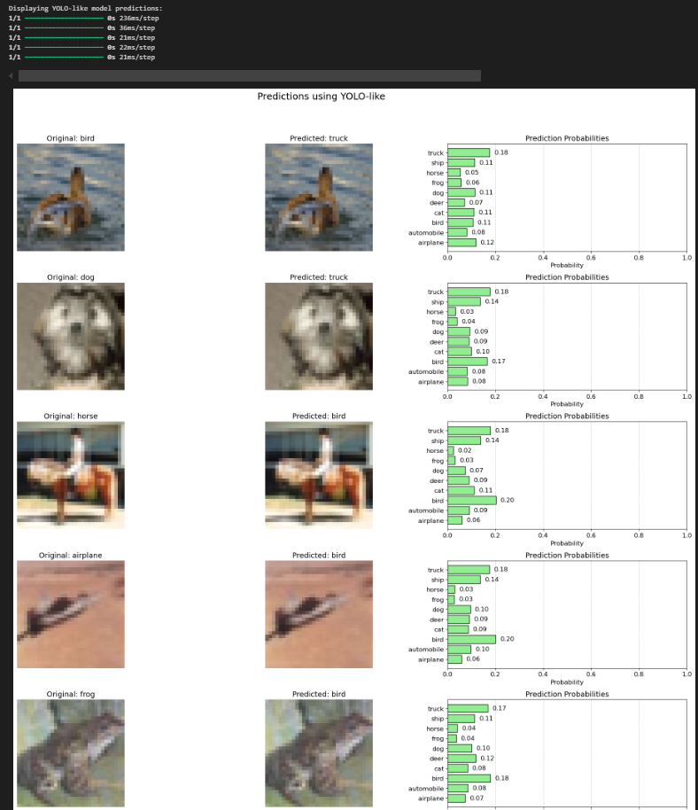

**CLASS WORK**

import numpy as np

import tensorflow as tf

from tensorflow.keras.models import Sequential

from tensorflow.keras.layers import Dense, Flatten, Conv2D, MaxPooling2D, SimpleRNN

from tensorflow.keras.datasets import mnist

from sklearn.model_selection import train_test_split

import matplotlib.pyplot as plt

# Load the MNIST dataset

(x_train, y_train), (x_test, y_test) = mnist.load_data()

# Normalize the data

x_train = x_train.astype('float32') / 255.0

x_test = x_test.astype('float32') / 255.0

# Reshape data for CNN (28x28x1) and RNN (28 timesteps, 28 features)

x_train_cnn = x_train.reshape(-1, 28, 28, 1)

x_test_cnn = x_test.reshape(-1, 28, 28, 1)

x_train_rnn = x_train.reshape(-1, 28, 28)

x_test_rnn = x_test.reshape(-1, 28, 28)

# Split the data into train and validation sets

x_train_cnn, x_val_cnn, y_train_cnn, y_val_cnn = train_test_split(x_train_cnn, y_train, test_size=0.2, random_state=42)

x_train_rnn, x_val_rnn, y_train_rnn, y_val_rnn = train_test_split(x_train_rnn, y_train, test_size=0.2, random_state=42)

# CNN model

cnn_model = Sequential([

    Conv2D(32, kernel_size=(3, 3), activation='relu', input_shape=(28, 28, 1)),

    MaxPooling2D(pool_size=(2, 2)),

    Flatten(),

    Dense(128, activation='relu'),

    Dense(10, activation='softmax')

])

cnn_model.compile(optimizer='adam', loss='sparse_categorical_crossentropy', metrics=['accuracy'])

cnn_history = cnn_model.fit(x_train_cnn, y_train_cnn, validation_data=(x_val_cnn, y_val_cnn), epochs=5, batch_size=128)

# RNN model

rnn_model = Sequential([

    SimpleRNN(128, input_shape=(28, 28)),

    Dense(10, activation='softmax')

])

rnn_model.compile(optimizer='adam', loss='sparse_categorical_crossentropy', metrics=['accuracy'])

rnn_history = rnn_model.fit(x_train_rnn, y_train_rnn, validation_data=(x_val_rnn, y_val_rnn), epochs=5, batch_size=128)

# Evaluate both models on the test set

cnn_test_loss, cnn_test_acc = cnn_model.evaluate(x_test_cnn, y_test)

rnn_test_loss, rnn_test_acc = rnn_model.evaluate(x_test_rnn, y_test)

# Print the results

print(f"CNN Test Accuracy: {cnn_test_acc}")

print(f"RNN Test Accuracy: {rnn_test_acc}")

# Plot the training history

plt.figure(figsize=(12, 5))

plt.subplot(1, 2, 1)

plt.plot(cnn_history.history['accuracy'], label='CNN Training Accuracy')

plt.plot(cnn_history.history['val_accuracy'], label='CNN Validation Accuracy')

plt.title('CNN Accuracy')

plt.xlabel('Epochs')

plt.ylabel('Accuracy')

plt.legend()

plt.subplot(1, 2, 2)

plt.plot(rnn_history.history['accuracy'], label='RNN Training Accuracy')

plt.plot(rnn_history.history['val_accuracy'], label='RNN Validation Accuracy')

plt.title('RNN Accuracy')

plt.xlabel('Epochs')

plt.ylabel('Accuracy')

plt.legend()

plt.show()

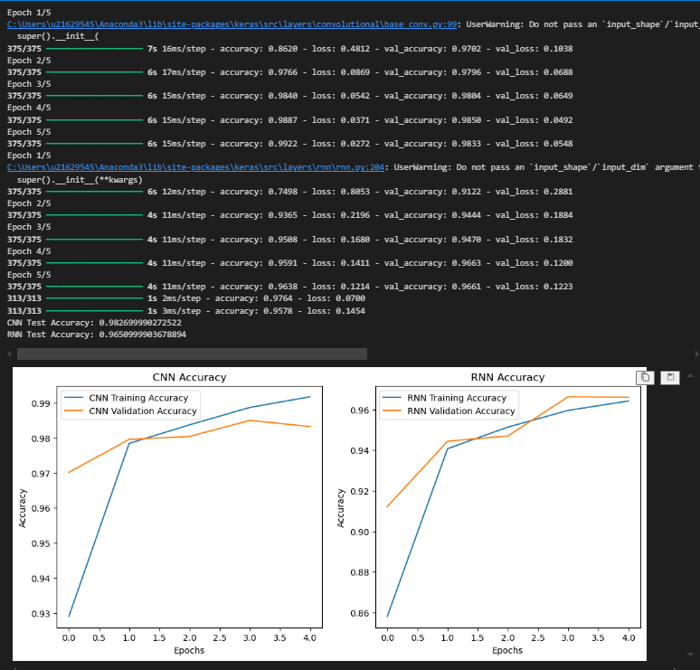

import numpy as np

import tensorflow as tf

from tensorflow.keras.models import Sequential

from tensorflow.keras.layers import Dense, Flatten, Conv2D, MaxPooling2D, UpSampling2D, Reshape, SimpleRNN, TimeDistributed, RepeatVector

from tensorflow.keras.datasets import mnist

import matplotlib.pyplot as plt

# Load the MNIST dataset

(x_train, _), (x_test, _) = mnist.load_data()

# Normalize the data

x_train = x_train.astype('float32') / 255.0

x_test = x_test.astype('float32') / 255.0

# Reshape data for CNN (28x28x1) and RNN (28 timesteps, 28 features)

x_train_cnn = x_train.reshape(-1, 28, 28, 1)

x_test_cnn = x_test.reshape(-1, 28, 28, 1)

x_train_rnn = x_train.reshape(-1, 28, 28)

x_test_rnn = x_test.reshape(-1, 28, 28)

# CNN autoencoder model

cnn_autoencoder = Sequential([

    # Encoder

    Conv2D(32, kernel_size=(3, 3), activation='relu', padding='same', input_shape=(28, 28, 1)),

    MaxPooling2D(pool_size=(2, 2), padding='same'),

    # Decoder

    Conv2D(32, kernel_size=(3, 3), activation='relu', padding='same'),

    UpSampling2D(size=(2, 2)),

    Conv2D(1, kernel_size=(3, 3), activation='sigmoid', padding='same')

])

cnn_autoencoder.compile(optimizer='adam', loss='binary_crossentropy')

cnn_autoencoder.fit(x_train_cnn, x_train_cnn, epochs=5, batch_size=128, validation_split=0.2)

# RNN autoencoder model

rnn_autoencoder = Sequential([

    # Encoder

    SimpleRNN(128, activation='relu', input_shape=(28, 28), return_sequences=False),

    RepeatVector(28),

    # Decoder

    SimpleRNN(128, activation='relu', return_sequences=True),

    TimeDistributed(Dense(28, activation='sigmoid'))

])

rnn_autoencoder.compile(optimizer='adam', loss='binary_crossentropy')

rnn_autoencoder.fit(x_train_rnn, x_train_rnn, epochs=5, batch_size=128, validation_split=0.2)

# Reconstruct images using both models

cnn_reconstructed = cnn_autoencoder.predict(x_test_cnn)

rnn_reconstructed = rnn_autoencoder.predict(x_test_rnn)

# Plot original and reconstructed images

n = 10  # number of images to display

plt.figure(figsize=(20, 4))

for i in range(n):

    # Display original

    ax = plt.subplot(2, n, i + 1)

    plt.imshow(x_test[i], cmap='gray')

    plt.title("Original")

    plt.axis('off')

    # Display CNN reconstructed

    ax = plt.subplot(2, n, i + 1 + n)

    plt.imshow(cnn_reconstructed[i].reshape(28, 28), cmap='gray')

    plt.title("CNN Reconstructed")

    plt.axis('off')

plt.figure(figsize=(20, 4))

for i in range(n):

    # Display original

    ax = plt.subplot(2, n, i + 1)

    plt.imshow(x_test[i], cmap='gray')

    plt.title("Original")

    plt.axis('off')

    # Display RNN reconstructed

    ax = plt.subplot(2, n, i + 1 + n)

    plt.imshow(rnn_reconstructed[i].reshape(28, 28), cmap='gray')

    plt.title("RNN Reconstructed")

    plt.axis('off')

plt.show()

import numpy as np

import tensorflow as tf

from tensorflow.keras.models import Sequential

from tensorflow.keras.layers import Dense, Flatten, Conv2D, MaxPooling2D, UpSampling2D, Reshape, SimpleRNN, LSTM, TimeDistributed, RepeatVector

from tensorflow.keras.datasets import mnist

import matplotlib.pyplot as plt

# Load the MNIST dataset

(x_train, _), (x_test, _) = mnist.load_data()

# Normalize the data

x_train = x_train.astype('float32') / 255.0

x_test = x_test.astype('float32') / 255.0

# Reshape data for CNN (28x28x1), RNN and LSTM (28 timesteps, 28 features)

x_train_cnn = x_train.reshape(-1, 28, 28, 1)

x_test_cnn = x_test.reshape(-1, 28, 28, 1)

x_train_rnn = x_train.reshape(-1, 28, 28)

x_test_rnn = x_test.reshape(-1, 28, 28)

# CNN autoencoder model

cnn_autoencoder = Sequential([

    # Encoder

    Conv2D(32, kernel_size=(3, 3), activation='relu', padding='same', input_shape=(28, 28, 1)),

    MaxPooling2D(pool_size=(2, 2), padding='same'),

    # Decoder

    Conv2D(32, kernel_size=(3, 3), activation='relu', padding='same'),

    UpSampling2D(size=(2, 2)),

    Conv2D(1, kernel_size=(3, 3), activation='sigmoid', padding='same')

])

cnn_autoencoder.compile(optimizer='adam', loss='binary_crossentropy')

cnn_autoencoder.fit(x_train_cnn, x_train_cnn, epochs=5, batch_size=128, validation_split=0.2)

# RNN autoencoder model

rnn_autoencoder = Sequential([

    # Encoder

    SimpleRNN(128, activation='relu', input_shape=(28, 28), return_sequences=False),

    RepeatVector(28),

    # Decoder

    SimpleRNN(128, activation='relu', return_sequences=True),

    TimeDistributed(Dense(28, activation='sigmoid'))

])

rnn_autoencoder.compile(optimizer='adam', loss='binary_crossentropy')

rnn_autoencoder.fit(x_train_rnn, x_train_rnn, epochs=5, batch_size=128, validation_split=0.2)

# LSTM autoencoder model

lstm_autoencoder = Sequential([

    # Encoder

    LSTM(128, activation='relu', input_shape=(28, 28), return_sequences=False),

    RepeatVector(28),

    # Decoder

    LSTM(128, activation='relu', return_sequences=True),

    TimeDistributed(Dense(28, activation='sigmoid'))

])

lstm_autoencoder.compile(optimizer='adam', loss='binary_crossentropy')

lstm_autoencoder.fit(x_train_rnn, x_train_rnn, epochs=5, batch_size=128, validation_split=0.2)

# Reconstruct images using all models

cnn_reconstructed = cnn_autoencoder.predict(x_test_cnn)

rnn_reconstructed = rnn_autoencoder.predict(x_test_rnn)

lstm_reconstructed = lstm_autoencoder.predict(x_test_rnn)

# Plot original and reconstructed images

n = 10  # number of images to display

plt.figure(figsize=(20, 6))

for i in range(n):

    # Display original

    ax = plt.subplot(3, n, i + 1)

    plt.imshow(x_test[i], cmap='gray')

    plt.title("Original")

    plt.axis('off')

    # Display CNN reconstructed

    ax = plt.subplot(3, n, i + 1 + n)

    plt.imshow(cnn_reconstructed[i].reshape(28, 28), cmap='gray')

    plt.title("CNN Reconstructed")

    plt.axis('off')

    # Display RNN reconstructed

    ax = plt.subplot(3, n, i + 1 + 2 * n)

    plt.imshow(rnn_reconstructed[i].reshape(28, 28), cmap='gray')

    plt.title("RNN Reconstructed")

    plt.axis('off')

plt.figure(figsize=(20, 4))

for i in range(n):

    # Display original

    ax = plt.subplot(2, n, i + 1)

    plt.imshow(x_test[i], cmap='gray')

    plt.title("Original")

    plt.axis('off')

    # Display LSTM reconstructed

    ax = plt.subplot(2, n, i + 1 + n)

    plt.imshow(lstm_reconstructed[i].reshape(28, 28), cmap='gray')

    plt.title("LSTM Reconstructed")

    plt.axis('off')

plt.show()

import numpy as np

import tensorflow as tf

from tensorflow.keras.models import Sequential

from tensorflow.keras.layers import Dense, Flatten, Conv2D, MaxPooling2D, UpSampling2D, Reshape, SimpleRNN, LSTM, TimeDistributed, RepeatVector

from tensorflow.keras.datasets import mnist

import matplotlib.pyplot as plt

# Load and preprocess the MNIST dataset

(x_train, _), (x_test, _) = mnist.load_data()

x_train = x_train.astype('float32') / 255.0

x_test = x_test.astype('float32') / 255.0

x_train_cnn = x_train.reshape(-1, 28, 28, 1)

x_test_cnn = x_test.reshape(-1, 28, 28, 1)

x_train_rnn = x_train.reshape(-1, 28, 28)

x_test_rnn = x_test.reshape(-1, 28, 28)

# Define CNN autoencoder model

cnn_autoencoder = Sequential([

    # Encoder

    Conv2D(32, kernel_size=(3, 3), activation='relu', padding='same', input_shape=(28, 28, 1)),

    MaxPooling2D(pool_size=(2, 2), padding='same'),

    # Decoder

    Conv2D(32, kernel_size=(3, 3), activation='relu', padding='same'),

    UpSampling2D(size=(2, 2)),

    Conv2D(1, kernel_size=(3, 3), activation='sigmoid', padding='same')

])

# Define RNN autoencoder model

rnn_autoencoder = Sequential([

    # Encoder

    SimpleRNN(128, activation='relu', input_shape=(28, 28), return_sequences=False),

    RepeatVector(28),

    # Decoder

    SimpleRNN(128, activation='relu', return_sequences=True),

    TimeDistributed(Dense(28, activation='sigmoid'))

])

# Define LSTM autoencoder model

lstm_autoencoder = Sequential([

    # Encoder

    LSTM(128, activation='relu', input_shape=(28, 28), return_sequences=False),

    RepeatVector(28),

    # Decoder

    LSTM(128, activation='relu', return_sequences=True),

    TimeDistributed(Dense(28, activation='sigmoid'))

])

# Compile models (no need to fit to display summaries)

cnn_autoencoder.compile(optimizer='adam', loss='binary_crossentropy')

rnn_autoencoder.compile(optimizer='adam', loss='binary_crossentropy')

lstm_autoencoder.compile(optimizer='adam', loss='binary_crossentropy')

# Print summaries of the models

print("CNN Autoencoder Summary:")

cnn_autoencoder.summary()

print("\nRNN Autoencoder Summary:")

rnn_autoencoder.summary()

print("\nLSTM Autoencoder Summary:")

lstm_autoencoder.summary()

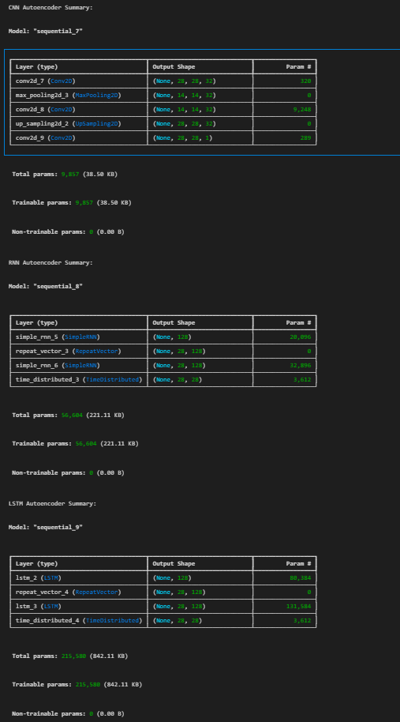

import numpy as np

import matplotlib.pyplot as plt

import seaborn as sns

from sklearn.metrics import confusion_matrix, classification_report

import tensorflow as tf

from tensorflow.keras.datasets import cifar10

from tensorflow.keras.models import Sequential

from tensorflow.keras.layers import Dense, Conv2D, MaxPooling2D, UpSampling2D, SimpleRNN, LSTM, TimeDistributed, RepeatVector, Flatten

from tensorflow.keras.optimizers import Adam

# Set memory growth for GPU (if available)

gpus = tf.config.experimental.list_physical_devices('GPU')

if gpus:

    try:

        for gpu in gpus:

            tf.config.experimental.set_memory_growth(gpu, True)

    except RuntimeError as e:

        print(e)

# Load and preprocess CIFAR-10 dataset

(x_train, y_train), (x_test, y_test) = cifar10.load_data()

x_train, x_test = x_train.astype('float32') / 255.0, x_test.astype('float32') / 255.0

# Reshape data for CNN and RNN/LSTM

x_train_cnn = x_train.reshape(-1, 32, 32, 3)

x_test_cnn = x_test.reshape(-1, 32, 32, 3)

x_train_rnn = x_train.reshape(-1, 32, 32 * 3)

x_test_rnn = x_test.reshape(-1, 32, 32 * 3)

class_names = ['airplane', 'automobile', 'bird', 'cat', 'deer',

               'dog', 'frog', 'horse', 'ship', 'truck']

# CNN autoencoder model

cnn_autoencoder = Sequential([

    Conv2D(32, kernel_size=(3, 3), activation='relu', padding='same', input_shape=(32, 32, 3)),

    MaxPooling2D(pool_size=(2, 2), padding='same'),

    Conv2D(32, kernel_size=(3, 3), activation='relu', padding='same'),

    MaxPooling2D(pool_size=(2, 2), padding='same'),

    Conv2D(32, kernel_size=(3, 3), activation='relu', padding='same'),

    UpSampling2D(size=(2, 2)),

    Conv2D(32, kernel_size=(3, 3), activation='relu', padding='same'),

    UpSampling2D(size=(2, 2)),

    Conv2D(3, kernel_size=(3, 3), activation='sigmoid', padding='same')

])

cnn_autoencoder.compile(optimizer='adam', loss='binary_crossentropy', metrics=['accuracy'])

cnn_history = cnn_autoencoder.fit(x_train_cnn, x_train_cnn, epochs=10, batch_size=128, validation_split=0.2)

# LSTM autoencoder model

lstm_autoencoder = Sequential([

    LSTM(128, activation='relu', input_shape=(32, 32 * 3), return_sequences=False),

    RepeatVector(32),

    LSTM(128, activation='relu', return_sequences=True),

    TimeDistributed(Dense(32 * 3, activation='sigmoid'))

])

lstm_autoencoder.compile(optimizer='adam', loss='binary_crossentropy', metrics=['accuracy'])

lstm_history = lstm_autoencoder.fit(x_train_rnn, x_train_rnn, epochs=10, batch_size=128, validation_split=0.2)

# RNN autoencoder model

rnn_autoencoder = Sequential([

    SimpleRNN(128, activation='relu', input_shape=(32, 32 * 3), return_sequences=False),

    RepeatVector(32),

    SimpleRNN(128, activation='relu', return_sequences=True),

    TimeDistributed(Dense(32 * 3, activation='sigmoid'))

])

rnn_autoencoder.compile(optimizer='adam', loss='binary_crossentropy', metrics=['accuracy'])

rnn_history = rnn_autoencoder.fit(x_train_rnn, x_train_rnn, epochs=10, batch_size=128, validation_split=0.2)

# Reconstruct images using all models

cnn_reconstructed = cnn_autoencoder.predict(x_test_cnn)

lstm_reconstructed = lstm_autoencoder.predict(x_test_rnn).reshape(-1, 32, 32, 3)

rnn_reconstructed = rnn_autoencoder.predict(x_test_rnn).reshape(-1, 32, 32, 3)

# Plot original and reconstructed images

n = 10  # number of images to display

plt.figure(figsize=(20, 9))

for i in range(n):

    # Display original

    ax = plt.subplot(4, n, i + 1)

    plt.imshow(x_test[i])

    plt.title("Original")

    plt.axis('off')

    # Display CNN reconstructed

    ax = plt.subplot(4, n, i + 1 + n)

    plt.imshow(cnn_reconstructed[i])

    plt.title("CNN Reconstructed")

    plt.axis('off')

    # Display LSTM reconstructed

    ax = plt.subplot(4, n, i + 1 + 2 * n)

    plt.imshow(lstm_reconstructed[i])

    plt.title("LSTM Reconstructed")

    plt.axis('off')

    # Display RNN reconstructed

    ax = plt.subplot(4, n, i + 1 + 3 * n)

    plt.imshow(rnn_reconstructed[i])

    plt.title("RNN Reconstructed")

    plt.axis('off')

plt.show()

# Function to plot class-wise precision, recall, and F1 score

def plot_classification_report(y_true, y_pred, model_name):

    report = classification_report(y_true, y_pred, target_names=class_names, output_dict=True)

    metrics = ['precision', 'recall', 'f1-score']

    plt.figure(figsize=(18, 6))

    for idx, metric in enumerate(metrics):

        plt.subplot(1, 3, idx+1)

        values = [report[label][metric] for label in class_names]

        bars = plt.barh(class_names, values, color='skyblue', edgecolor='black')

        plt.title(f'{metric.capitalize()} per Class', fontsize=16)

        plt.xlim(0, 1)

        plt.grid(axis='x', linestyle='--', alpha=0.7)

        plt.xlabel(metric.capitalize(), fontsize=14)

        plt.xticks(fontsize=12)

        plt.yticks(fontsize=12)

        for bar in bars:

            plt.text(bar.get_width() + 0.02, bar.get_y() + bar.get_height()/2, f'{bar.get_width():.2f}', va='center', fontsize=12)

    plt.suptitle(f'{model_name} Class-wise Performance Metrics', fontsize=18)

    plt.tight_layout(rect=[0, 0, 1, 0.95])

    plt.show()

# Simulate predicted labels for evaluation (mock example)

y_pred_cnn = np.random.randint(0, 10, size=len(y_test))  # Replace with actual predictions

y_pred_lstm = np.random.randint(0, 10, size=len(y_test))

y_pred_rnn = np.random.randint(0, 10, size=len(y_test))

# Plot classification reports for CNN, LSTM, and RNN

def evaluate_model(y_true, y_pred, model_name):

    print(f"\n{model_name} Classification Report:\n")

    print(classification_report(y_true, y_pred, target_names=class_names))

    plot_classification_report(y_true, y_pred, model_name)

evaluate_model(y_test, y_pred_cnn, "CNN Autoencoder")

evaluate_model(y_test, y_pred_lstm, "LSTM Autoencoder")

evaluate_model(y_test, y_pred_rnn, "RNN Autoencoder")



